|  |  |
| --- | --- |
|  | horizontal line Abhay Sawhneyamsawhney@ucdavis.edu / 530-761-3475 Baritone who loves theater and rock music!  UC Davis, class of 2021  3.9 GPA in Dramatic art  Rockschool UK, class of 2016  Grade 8 Vocals passed with Merit, all-India topper for Grade 7 Vocals |
| **ㅡ** Stats Height: 6’0”  Weight: 175 lbs  Eyes: Brown  Hair: Black  Vocal range: E2-F4/C5  **ㅡ** Skills Singing  Improv comedy  Guitar  Salsa/Bachata  Rapping/Freestyling  Stage combat  Hyping up a crowd (Andrew Schulz) | horizontal line Fun & Flirty *(comedy)* / Standup comic2023-2024, SEATTLE Standup comedy to pitch/be pitched on a comedy dating show Azure Year-in-review *(dance video)* / Lead male dancer2021, SEATTLE High budget 2-day shoot with Anna Matuszewski (Macklemore’s choreographer) Hella Mega Tour *(concert)* / Guest guitarist2021, SEATTLE Played with Green Day for 40,000 people at T-Mobile Park Cherry Pie Comedy *(improv)* / Lead performer2018-2019, DAVIS Weekly shows with lots of social satire Pippin *(musical)* / Lewis2018, DAVIS Supporting lead, highly physical role involving swordplay/wrestling/lifts Heathers *(musical)* / Ram2018, DAVISSwimmers *(play)* / Randy2018, DAVIS **Studio 301’s Miscast Revue** *(musical revue)***/** Helene Kuragin 2017, DAVISOvercast *(band)* / Lead Vocals & Rhythm Guitar2013 - 2016, NEW DELHIThe Sneeze *(play)* / Cherdyakov2012, NEW DELHI |

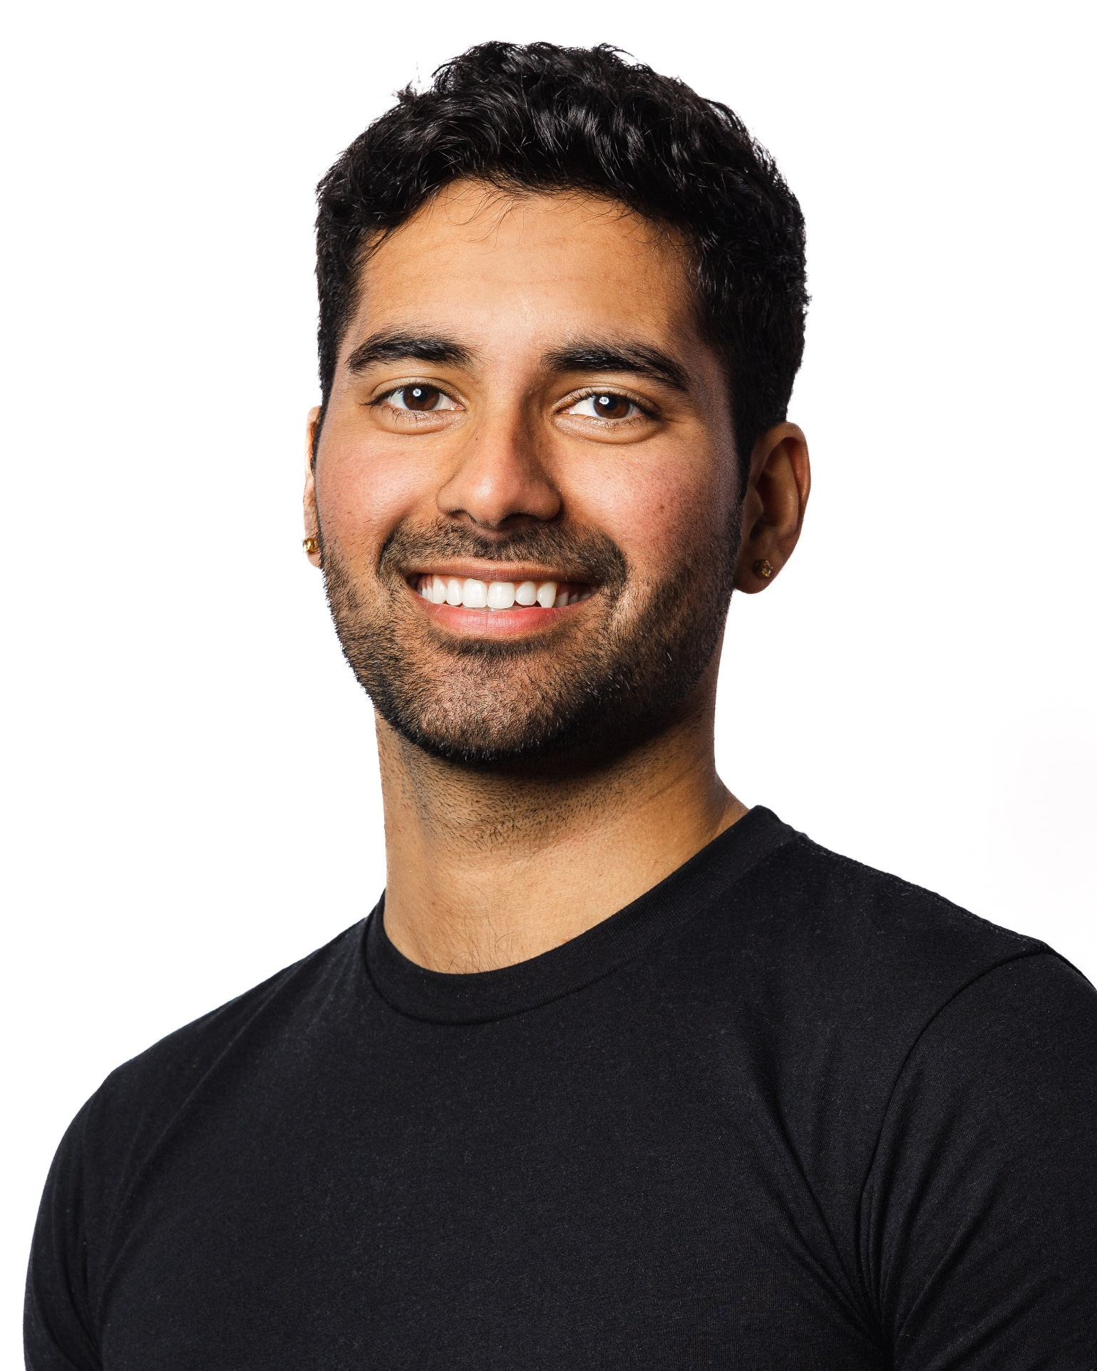

# Abhay Manu Sawhney